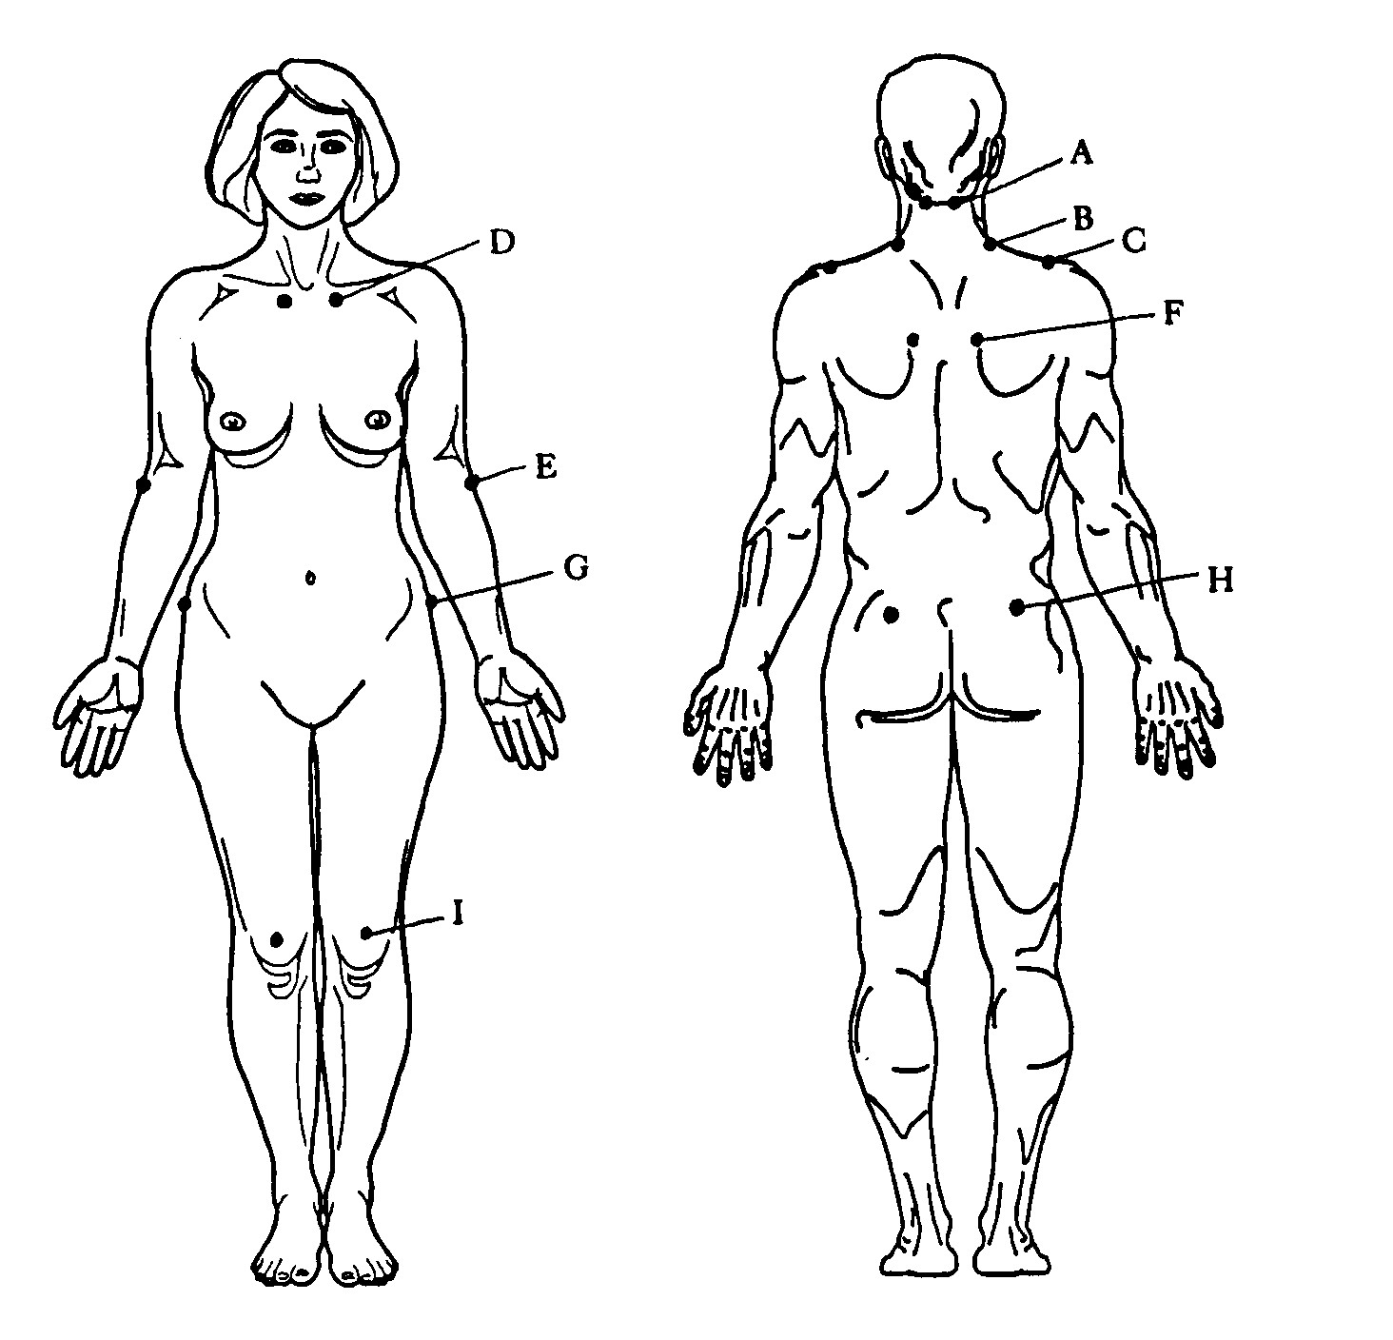
Tender Points in Fibromyalgia
These tender places occur symmetrically on both sides of the body:
A. at the base of the skull beside the spinal column;
B. at the base of the neck in the back;
C. on the top of the shoulder toward the back;
D. on the breastbone;
E. on the outer edge of the forearm about 2 cm below the elbow;
F. over the shoulder blade;
G. at the top of the hip;
H. on the outside of the hip; and
I. on the fat pad over the knee.
To get a formal diagnosis of FM, your doctor must find at least 11 of these 18 tender points. However, what is tender on one day may not be on another. Therefore, if you have some number less than 11 but meet the other criteria for FM (widespread pain, muscular stiffness, and difficulty getting restful sleep) you would do well to follow a good regimen for managing FM even though you don't have all the required tender points.

